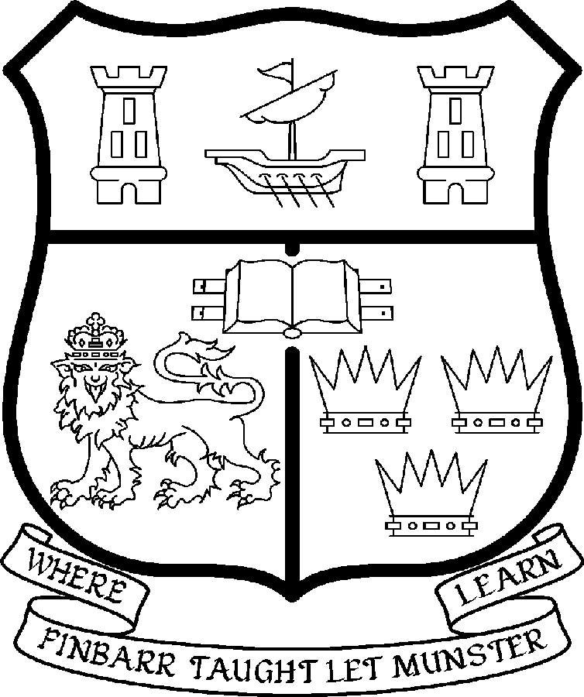 | UNIVERSITY COLLEGE CORK  Coláiste na hOllscoile Corcaigh
LECTURESHIP IN PLANNING AND SUSTAINABLE DEVELOPMENT
(COLLEGE LECTURER 1 - THREE YEAR CONTRACT POST)

Particulars of Post

1. The Lectureship in Planning and Sustainable Development is a wholetime three year contract post, This College Lecturer post, based in the UCC Programme in Planning and Sustainable Development, is attached to the Department of Applied Social Studies based in the College of Arts, Celtic Studies and Social Sciences. The appointee shall work under the direction of the Director of the programme and shall discharge such duties as shall be assigned to him/her by the said Head. The position is tenable from September 2008.

The current remuneration – [new entrants] – is as detailed below. The appointment to the post of Lecturer in Planning and Sustainable Development will be made at a point on the following scale in accordance with qualifications and experience to date.

 | € |  | €
Minimum | 36,500 | Eighth Point | 51,656
Second Point | 38,616 | Ninth Point | 53,956
Third Point | 41,037 | Tenth Point | 55,707
Fourth Point | 43,120 | Eleventh Point | 57,497
Fifth Point | 45,308 | Maximum | 59,293
Sixth Point | 47,614
Seventh Point | 49,452

Bar

First point | 64,974 | Fourth point | 78,400
Second point | 69,450 | Fifth point | 85,592
Third point | 73,934

The salary includes a premium of 1/19th for pensionable staff paying contributions. Class A1 rate of Pay Related Social Insurance (PRSI) applies to the post which is currently 4% with an earnings ceiling of €50,700.

- Duties of the Post:

The duties of the Lecturer shall be to teach under the direction of the Director of the MPlan Progamme. S/he shall examine in relevant programmes for the University and shall carry out such other duties appropriate to the post as detailed below:

Under the supervision of the programme Director, the appointee will contribute to course development, maintenance of professional accreditation, establishment of the planning research capacity of UCC, and be a key member of the planning team teaching the M.Plan masters course.

The appointee will, inter alia:

- Report to the Director of UCC’s Programme in Planning and Sustainable Development.
- Contribute to the co-ordination, delivery, examination and future development of the M.Plan and other teaching initiatives.
- Contribute to developing, strengthening and maintaining UCC’s research capacity in the area of spatial planning and sustainable development.
- Contribute to securing and maintaining the professional accreditation of the M. Plan by the IPI and RTPI and other professional bodies where required.
- Establish professional education and practice linkages with planning practitioners, professional bodies and other relevant parties.
- Prepare and assist in the preparation of applications for research funding.
- Supervise and co-supervise graduate-student research.
- Ensure an excellent reputation for scholarship by participating in national, and international conferences, and professional and research networks.
- Publish work to the highest standard.
- Teach and examine at undergraduate level and undertake additional duties and administrative duties as directed by the programme Director.
- Report on an ongoing basis to programme Director, course executive and Board of Studies of M.Plan.
- Deputise for the programme Director when required.
- Undertake teaching, administrative or other tasks as directed by the Head of the Department of Applied Social Studies (subject to agreement with the programme Director).
- Attend and maintain membership of relevant departmental and university committees/boards.
- Contribute to the academic life of the University.

The above listing is not exclusive or exhaustive and the post holder may be required to undertake any such duties as may reasonably be expected. All staff are required to be flexible and co-operative and professional within the needs of the post and the Department/School, College and University. The University is undertaking a major reform of its internal structures which may necessitate possible future changes in the organisation of its activities.

3. Selection Criteria:

Decisions made at shortlisting, presentation and interview will be made based on the following criteria:

Essential Criteria

The successful candidate will have:

- A professionally recognised qualification in planning (including eligibility for corporate membership of the IPI or Chartered membership of the RTPI or an equivalent international qualification).
- Competence to teach and examine on current and future undergraduate and postgraduate programmes.
- A minimum of three years post-qualifying planning experience in a relevant planning body, research institution or academic department.
- A well developed post-qualifying track record in planning research and teaching or a strong portfolio of post-qualifying professional experience in the field of planning and sustainable development.
- A proven record of innovation in the planning field.
- Strong interest in planning research and publishing.
- Potential to raise funds to support the research activities of the programme.
- Excellent communication and interpersonal skills.
- Ability to work in a multi-disciplinary environment.
- Administrative capabilities.

Desirable Criteria

- International experience, specialist knowledge in one or more planning fields.
- An understanding of multidisciplinary work environments.
- A demonstrable interest in planning education and research.
- An enthusiasm for breaking new ground in planning education and research in Ireland.

Candidates are requested to make a personal assessment of these criteria against their own qualifications, skills and abilities to assess whether they should apply for the post.

- The normal Statutory or other provisions relating to full-time Lectureships and Senior Lectureships shall apply to the post.

- For an informal discussion about these posts, please contact the Director of the UCC Programme in Planning and Sustainable Development, Muskerry Villas, Western Road, Cork, Ireland. Tel no: +353 (0)21 490 4356 or e-mail brendan.osullivan@ucc.ie

- Each candidate must complete an application form, which can be downloaded at:
http://www.ucc.ie/en/hr/FormsContractDocuments/DocumentFile,35042,en.doc. Please clearly indicate the name of the post which you wish to apply for.

- Candidates shortlisted for posts shall be required to appear in person before a Board of Assessors in Cork, in which case travelling and subsistence expenses at approved rates will be paid.

- A successful candidate will be required to submit a birth certificate, documentary evidence confirming academic qualifications, and to undergo a medical examination.

- References will be sought in relation to all candidates invited to attend for interview

- An offer of appointment to a candidate who is not EU nationality is subject to the granting of a Work Permit by the Department of Enterprise Trade & Employment.

- Candidates may be required to produce documentary evidence to support any statements made by them on their application form or any supporting documentation. Candidates should note that any inaccurate information will invalidate their application.

- Completed application forms must reach Recruitment Office, Department of Human Resources, University College, Cork, Ireland, on or before Friday 23rd May 2008. Tel: +353-21-4902671 Email: recruitment@per.ucc.ie. Fax. +353-21-4276995.

UNIVERSITY COLLEGE CORK IS AN EQUAL OPPORTUNITIES EMPLOYER
GENERAL INFORMATION FOR CANDIDATES

Introduction to University College Cork

University College Cork, a constituent University of the National University of Ireland, is a collegiate, progressive, dynamic research-led university developing a reputation as a world class regional university, built on the history of significant achievements in teaching and learning and research, and strong academic and professional leadership.

The University has a current enrolment of over 17,000 students with a strategic objective of 21,000 by 2011. UCC currently has 1,400 academic and research staff within a total staff compliment of 2,500.

Founded in 1845, as Queen’s College, Cork, UCC is one of Ireland’s oldest institutions of higher learning. The rich history and tradition of UCC is reflected in the imposing limestone buildings of the Main Quadrangle and the mature grounds. UCC’s scenic city centre campus, boasting award-winning architecture, provides a pleasant and vibrant learning environment, which is given an international dimension by the presence of 2,000 international students and many staff from over 75 countries around the world.

UCC is one of the premier research institutions in the State and its research income is consistently one of the highest in the country. The University earns peer-reviewed research income in excess of €60m per annum, has strategic research partnerships with leading multinationals in the agri-food, microelectronics, and pharmaceutical sectors, and is home to 5 of Ireland’s 8 ISI Most Highly Cited authors. The university’s research reputation spans across the broad range of disciplines, strategically built around a number of internationally-recognised Research Institutes, Centres and Departments.

UCC is fully committed to the development of 4th level training and research through the introduction of Graduate Schools and structured PhD programmes and the provision of a wide range of generic and discipline-specific modules supporting the research activity of PhD students. The University offers an innovative, research-led curriculum, taught by world-class academics who consistently attract a quality student intake.
Recent institutional reorganisation has established four Colleges; Arts, Celtic Studies and Social Sciences; Business and Law; Medicine and Health; Science, Engineering and Food Science. The Colleges offer over 120 degree and professional programmes that consistently attract the highest proportion of top school leavers in the country and supports a rapidly growing postgraduate and international student body.

The University has embarked on a programme of development for UCC to firmly establish it as a world-class regional university building on the guiding principles in the University’s Strategic Framework 2006-2011 of excellence in teaching, learning, research and contribution to community and society. UCC will focus on research performance, the quality of the student experience and the manner in which the institution discharges its regional role.

Having twice being designated as the Sunday Times “Irish University of the Year” in the past four years, UCC is also a recent proud recipient of the “Excellence Through People” Gold Standard.

The last five years have seen exceptional growth in student numbers, award winning capital developments supporting science, technology and the arts and significant success in winning research funding, making it in that time the most research active institution in the country.

UCC enjoys excellent links with local business and enterprise along with strong partnerships with some of the world’s most highly valued companies. Relationships with professional and public bodies across a wide range of disciplines are equally a key feature of the University.

Internationalisation of the campus continues to be a key strategic objective of UCC. International enrolment at UCC is among the highest in the sector creating a multi- cultural and ethnically diverse student body and measures taken by UCC to enhance conditions for international student recruitment are regarded as among the best practices by peer institutions. UCC also provides opportunities for Irish students to study overseas making them competitive in a global market. In recent years new exchange opportunities include academic placements in a diverse range of European, US, Canadian and Australian universities, with new developments targeting China.

Staff are essential to the achievement of our mission and UCC places a special emphasis on quality improvement strategies in Human Resource Management. A key objective of the UCC Strategic Framework 2006-2011 is to attract, develop and retain outstanding staff through the development and implementation of best practice HR policies and procedures. We seek to develop staff capable of keeping the University at the forefront in all that it does. The University has committed to establishing a supportive working environment in which the needs of all staff are recognised and their contributions valued and rewarded.

The UCC Programme in Planning and Sustainable Development launched its interdisciplinary M.Plan degree course in 2006. Its first cohort of students will sit final examinations next May. This exciting new programme, which attracts high calibre students from a wide variety of disciplines, has a real-world contemporary focus with firm foundations in academic thought, applied research and professional planning practice.

Web Links
UCC website
http://www.ucc.ie/en/

UCC Strategic Plan 2006-2011
http://www.ucc.ie/en/PresidentsOffice/UCCsStrategicPlan/DocumentFile,1005,en.pdf

Full details about the programme, including staff and student profiles, details of professional accreditation etc. are available on http://mplan.ucc.ie

